**i Revolution: A Data-driven Exploration of Apple’s iPhone Impact in India**

1. **Introduction:**
   1. **Overview**

**The world has changed as a consequence of the increasing use of smartphones,which have improved communication,connected people, and revolutionized many different businesses.With its main product,the iPhone,capturing markets around the world,Apple Inc. Has emerged as a prominent player among the top smartphone makers. India,one of the economies with the greatest economic growth,has seen atremendous increase in smartphone usage,making it an interesting market to study the effects of Apple’s iPhone.**

**In order to shed light on important factors like market penetration,customer preferences,economic ramifications,and societal changes,this research report will perform a data-driven investigation of the impact of the iPhone in India.This study will offer in available insights into the tranformative impact of the iPhone on India’s technological landscape and the lives of its customers by using advanced data analytics techniques and analyzing large datasets.**

* 1. **Purpose:**

**Apple has a special chance to increase its market share and develop a significant presence in India thanks to the country’s large population and rising smartphone adoption.Each new iPhone model unveiling generates excitement and anticipation among Indian buyers.By utilizing the plethora of information Already accesible, this research aims to go beyond conjecture and anecdotal evidence in order to develop a through knowledge of the effects of the iPhone.**

1. **Problem definition & Design Thinking:**
   1. **Empathy Map:**

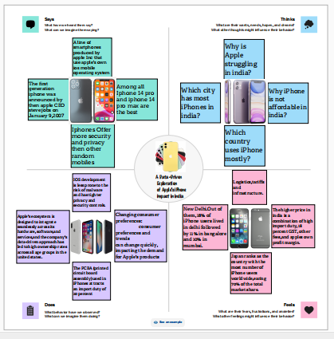

* 1. **Ideation & Brainstorming Map**

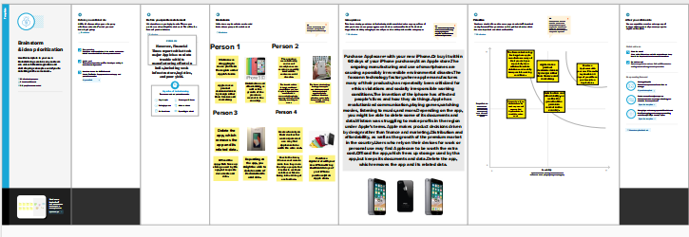

1. **Result:**

**3.1 Dashboard:**

**A dashboard is a graphical user interface that displays information and data in on organized,easy-to-read format.Dashboards are often used to provide real-time Monitoring and analysis of data,and or typically designed for a specific purpose or use case.Dashboards can be used in a variety of settings ,such as business,finance,manufacturing,health care,and many other industries.They can be used to track key performance indicators,monitor performance metrics,and display data in the form of charts,graphs,and tables.**

**Dashboard 1:**

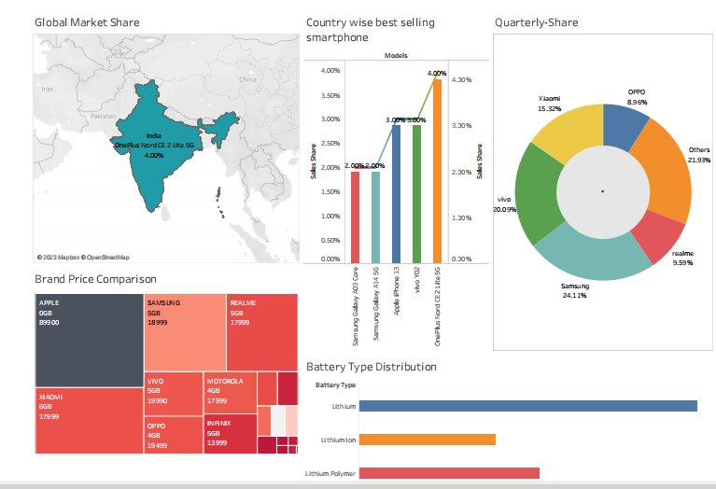

**Dashboard 2:**

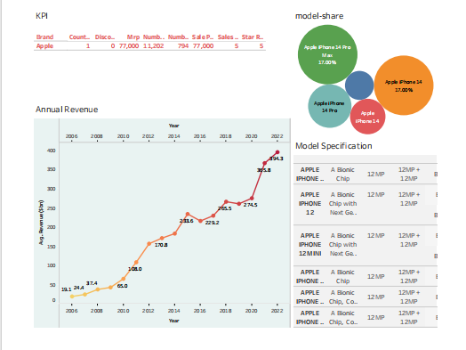

**3.2 Story**

**A data story is a way of presenting data and analysis in a narrative format,with the goal of making the information more engaging and easier to understand.A data story typically includes a clear introduction that sets the stage and explains the context for the data,a body that presents the data and analysis in a logical and systematic way, and a conclusion that summarizes the key findings and highlights their implications. Data stories can be told using a variety of mediums, such as reports, presentations,interactive visualizations,and videos.**

**Story 1**

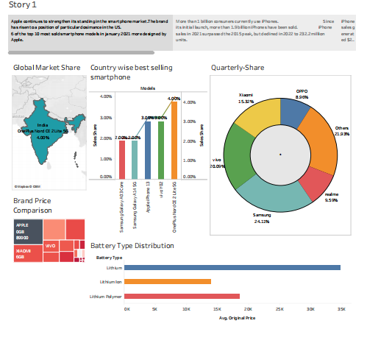

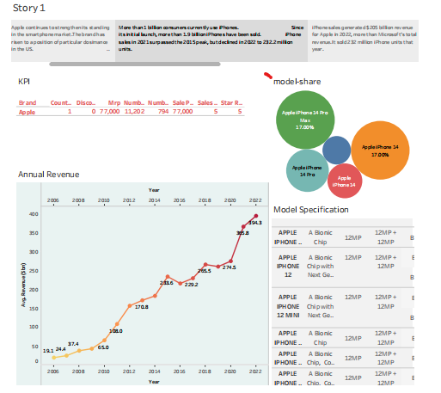

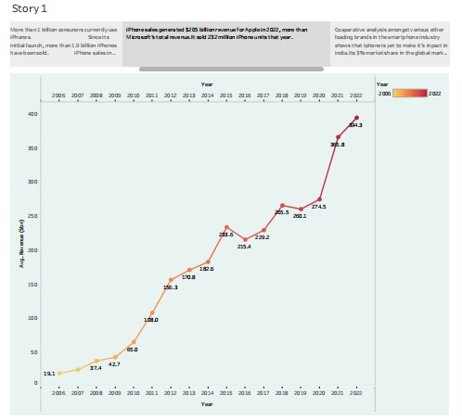

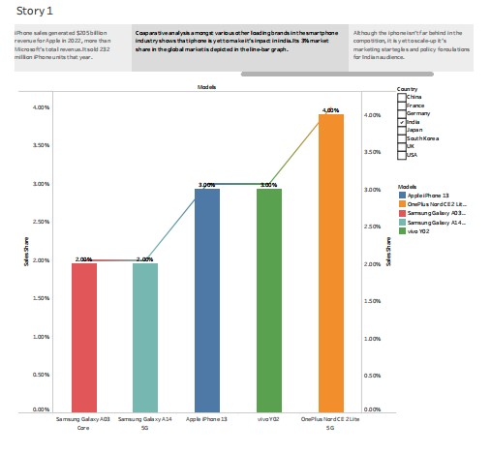

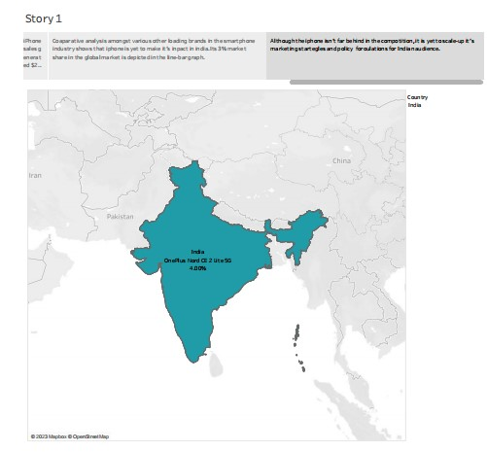

**4.ADVANTAGES**

**The iPhone for a business is lightweight and portable, so you can take it wherever you go.It has a long battery life, so you don’t have to worry about running out of power when you need it most. The iPhone’s powerful applications give you access to all your office tools in a simple, intuitive interface.**

**5.DISADVANTAGES**

**These smartphones are not only fun and interesting to have in your hand they can also bring serious harm to your mental health apart from cancer risk, mobile devices influence our nervous system. They may causes headaches, decreased attention, shortness of temper.Sleep disorders and depression mostly among teenagers.**

**6.APPLICATION**

**As the California-based company looks to diversify its supply chain away from chain, it has been increasing the production of its popular product in the country. In the financial year 2002-23, Apple produced 7 per cent of its total iPhones in indian.Indian became Apple’s fifth largest iPhone market in the second quarter for the first time. Overtaking France and Germany , according to counterpoint Research. India contributed close to 4% of all iPhone sales in the second quarter, growing 50% year-on-year.**

**7.CONCLUSION**

**In summary, it is apparent that iPhone was, and still, a remarkable invention of technological advancement. The iPhone provided a new way of mobile phone communication and usability. Its revolutionary technology has led to the variety of smartphones that are in use today.**

**8.FUTURE SCOPE**

**The iPhone dramatically changed the way people communicate, learn, play and work. With an iphone in hand, an employee could work from home or be on site with a client and still have access to compny data and be connected. The iPhone popularized the use of apps, web tools and mobility.**